 | SAKR MANNING AGENCY  FOR RECRUITING EGYPTIAN LABOR ABROAD | Issue Date | 15.05.2022
 |  | Revision Date | 27.05.2023
 | Crewing Management Manual  Seafarer Employment Application | Revision | 1.2
 |  | Page | 3
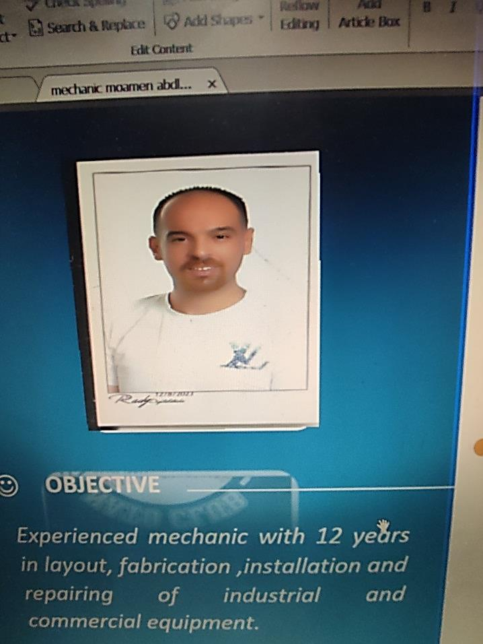
Application For Position as | Able Seafarer engine
Register Code.
Other Position (If Any) | Able Seafarer engine
Register Date
Last up Date Data | 2/9/2023
Expected Salary

1. PERSONAL DETAILS
Full Name |  | Moamen Abdelhalim Abbas
Date Of Birth |  | 23/8/1986 |  |  |  |  |  |  | Place Of Birth |  |  |  |  |  |  |  | Alexandria  √
Nationality |  | Egyptian |  |  |  |  |  |  | Marital Status |  |  |  |  |  |  |  | Single |  |  |  |  |  |  |  | Married
Height (Cm) |  | 189 |  |  |  |  |  |  | Overall Size |  |  |  |  |  |  |  | 62 |  |  |  |  | Shirt Size |  |  |  |  |  | 2 x
Weight (Kg) |  | 90 |  |  |  |  |  |  | Trouser Size |  |  |  |  |  |  |  | 38 |  |  |  |  | Shoes Size |  |  |  |  |  | 45
2. EDUCATION
College / School |  | Martyr Ismail Fahmy School
Marline Test |  | Issued Date |  |  |  |  | Result % |  |  |  | Issued By (Authority) |  |  |  |  |  |  |  |  |  | Issued At
 |  |  |  |  |  |  |  |  |  |  | √
English Language |  | Fluent |  |  |  |  |  | Good  √ |  |  |  |  | Average |  |  |  |  |  |  |  | Poor
Arabic Language  ( ) |  | Fluent |  |  |  |  |  | Good |  |  |  |  | Average |  |  |  |  |  |  |  | Poor
3. CONTACT DETAILS
Home Address / City |  |  | 1 Al farah Street - Krmoz – Alexandria
E-Mail |  |  | moumenabdelhalim@gmail.com |  |  |  |  |  |  | Mobile / Tel |  |  |  |  |  | 01223613322

4. TRAVEL DOCUMENTS
Type |  | Document No. |  |  |  | ISS. Date |  |  | Exp. Date |  |  |  |  | ISS. By (Authority) |  |  |  |  |  |  |  |  |  | Place of Issue
Passport |  | A34775745 |  |  |  | 14/8/2023 |  |  | 13/8/2030 |  |  |  |  | Egyptian Authority |  |  |  |  |  |  |  |  |  | Alex
Seaman Book |  | S00019448 |  |  |  | 21/11/2021 |  |  | 16/5/2026 |  |  |  |  | EAMS |  |  |  |  |  |  |  |  |  | Alex
Other Seaman Book |  | CY343159 |  |  |  |  |  |  | 22/3/2032 |  |  |  |  | cyprus |  |  |  |  |  |  |  |  |  | cyprus

5. PROFESSIONAL QUALIFICATION / CERTIFICATE OF COMPETENCY
Certificate Name |  |  |  |  | Number | Issue Date |  |  |  |  |  | Expiry Date |  |  |  |  |  | Issued By |  |  |  |  |  |  |  |  | Issued At
COC ( Rank) ………….. |  |  |  |  |  |  |  |  |  |  |  |  |  |  |  |  |  | EAMS |  |  |  |  |  |  |  |  | Alex.
GOC |  |  |  |  |  |  |  |  |  |  |  |  |  |  |  |  |  | NTRA |  |  |  |  |  |  |  |  | Cairo
D.P. INDUCTION
D.P. ADVANCED
D.P. OPERATOR (UNLIMITED)
6. NEXT OF KIN
Full Name | Elsayed Rezk Elsayed |  |  |  |  |  |  |  |  |  |  |  |  |  | Relationship |  |  |  |  | Uncle
Address | Agamy – Alexandria
Tel. No. | 034370760 |  |  |  |  |  |  |  |  | Mobile |  |  | 01282802990
7. HEALTH CERTIFICATES & VACCINATIONS
Flag State |  |  |  | Number |  |  | Issue Date |  |  |  |  | Expiry Date |  |  |  |  |  |  | Issued By |  |  |  |  |  |  | Issued At
International Medical |  |  |  |  |  |  | 01/09/2024 |  |  |  |  | 31/08/2026 |  |  |  |  |  |  | EAMS |  |  |  |  |  |  | Alex.
Yellow Fever |  |  |  | 65611 |  |  | 2005 |  |  |  |  | Un limited |  |  |  |  |  |  | Ministry of Health
Cholera |  |  |  |  |  |  |  |  |  |  |  |  |  |  |  |  |  |  | Ministry of Health
Covid-19 |  |  |  | Vaccination Name |  |  | First Dose |  |  |  |  | Second Dose |  |  |  |  |  |  | (Other Does or Remarks)
 |  |  |  | Johnson

8. MARINE COURSES
Course Name | Number | Issue Date | Expiry Date | Issued By / At
Personal Survival Techniques | A-VI/1-1 | 9/5/2021 | 28/8/2026 | Arab academy
Proficiency In Personal Survival Techniques
Fire Prevention and Fire Fighting | A-VI1-2 | 9/5/2021 | 28/4/2026 | Arab academy
Advanced Fire Prevention and Fire Fighting
Elementary First Aid | A-VI1-3 | 9/5/2021 | 28/4/2026 | Arab academy
Medical Care Studies
Personal Safety and Social Responsibilities | A-VI/1-4 | 9/5/2021 | 28/4/2026 | Arab academy
Proficiency Of Security Awareness Training Seafarers | A-VI/6 | 24/42021 | 20/42026 | Arab academy
Proficiency as a ship Security officer ( PSSO )
Proficiency In Survival Craft & Rescue Boats | A-VI/2-1 | 25/4/2021 | 21/4/2026 | Arab academy
G.M.D.S.S
Communications
Advanced Communications
ECDIS Advanced Simulator (Management Level)
ECDIS Simulator (Operation Level)
Prevention and Combating of Marine Pollution
Radar & ARPA Simulator and Search &rescue
ARPA Simulator and Search
Marine Radar and automatic Radar Plotting
Bridge resource Management (B.R.M)
Engine resource Management (E.R.M)
Navigational Watch keeping
Proficiency for Rating forming part of Navigational watch (II/4) |  |  |  | EAMS / Alex.
High voltage training – operation of ship (1000 Volt and More)
Passenger Safety Cargo Safety and Hull integrity
Crowd Management Training
Crisis Management and Human Behavior Training
Safety training for Personal Prov. Direct Passengers
Practical Ability to Prepare Meals and (MLC 2006)
Personal Hygiene and Envir. Protection (MLC 2006)
Safety and Health in the Provision Meals (MLC 2006)
Food Storage and inventory Control (MLC 2006)
Ships Cook Certificate (MLC 2006) |  |  |  | EAMS / Alex.
Abel Seafarer Deck
Proficiency for Abel Seafarer Deck ( II/5 ) |  |  |  | EAMS / Alex.
Engineering Watch keeping | Stcw95 | 26/2/2008 | UN LIMITED | EAMS / Alex.
Proficiency for Rating forming part of a watch in engine room
Abel Seafarer Engine | AIII/5 | 24/112021 | UN LIMITED | Arab academy
Proficiency for Abel Seafarer Engine ( III/5 ) | ^{III/5} | 8/12/2021 | UN LIMITED | Arab academy
Electro Technical Rating
Proficiency for Electro Technical rating ( III/7 ) |  |  |  | EAMS / Alex.

 |  |  | COMPLETE SEA – SERVICE DETAILS
Name: |  |  |  |  |  |  |  |  |  |  |  |  |  |  |  | Rank: |  |  |  |  | Register Code:
Company Name |  |  |  |  |  | Rank | Vessel Name |  |  | Flag |  |  | Signed On |  |  |  |  | Signed Off |  |  | Period |  | Vessel Type |  |  |  | D.W.T. |  |  | Engine Type |  | BH |  |  |  | KW
BSM |  |  |  |  |  | MOTOR MAN | GODDESS OF THE NIGHT  9239795 |  |  | Antigua and Barbuda |  |  | 27/09/2024 |  |  |  |  | 15/05/2025 |  |  |  |  | PASSENGER |  |  |  | 9859 |  |  | sulzer |  | 63000 KW
GLORY DENIZCILIK VE GEMI |  |  |  |  |  | MOTOR MAN | IMMENSITY  9171395 |  |  | PANAMA |  |  | 27/10/2023 |  |  |  |  | 2/7/2024 |  |  |  |  | G.CARGO |  |  |  | 9766 |  |  | Wartsila |  | 2760 KW
SALAMIS LINES LTD |  |  |  |  |  | MOTOR MAN | AKRITAS  8020599 |  |  | CYPRUS |  |  | 15/11/2022 |  |  |  |  | 7/8/2023 |  |  |  |  | RORO CONTAINER |  |  |  | 13030 |  |  | PIELSTICK  12PC2-5V-400 |  | 17400 KW
SALAMIS LINES LTD |  |  |  |  |  | MOTOR MAN | AKRITAS  8020599 |  |  | CYPRUS |  |  | 30/1/2022 |  |  |  |  | 21/9/2022 |  |  |  |  | RORO CONTAINER |  |  |  | 13030 |  |  | PIELSTICK  12PC2-5V-400 |  | 17400 KW
NAIF MARINE SERVICES CO PSC |  |  |  |  |  | MOTOR MAN | JABAL ALI 1  7314979 |  |  | UAE |  |  | 13/6/2021 |  |  |  |  | 5/11/2021 |  |  |  |  | RORO CONTAINER |  |  |  | 2642 |  |  | KAWAZAKI MAN 6L |  | 12000 KW
NAIF MARINE SERVICES CO PSC |  |  |  |  |  | OILAR | JABAL ALI 5  7304340 |  |  | Comoros |  |  | 25/8/2020 |  |  |  |  | 14/4/2021 |  |  |  |  | RORO CONTAINER |  |  |  | 5375 |  |  | MITSUI B&W |  | 5914 KW
BAHRAINI COMPANY |  |  |  |  |  | OILAR | AVONMOOR  9145279 |  |  | Bahrain |  |  | 13/5/2017 |  |  |  |  | 29/12/2017 |  |  |  |  | CONTAINER |  |  |  | 8918 |  |  | Wartsila  6L46A |  | 6300 KW
AL-BEIRUTI SYRIAN COMPANY |  |  |  |  |  | OILAR | MALMO  8116738 |  |  | Tanzania |  |  | 17/2/2013 |  |  |  |  | 6/12/2013 |  |  |  |  | G.CARGO |  |  |  | 11744 |  |  | MAN  6m601 |  | 4412 KW
AL-BEIRUTI SYRIAN COMPANY |  |  |  |  |  | OILAR | STAR PRINSE 7625706 |  |  | KINGSTONE |  |  | 2/5/2012 |  |  |  |  | 29/12/2012 |  |  |  |  | CARGO |  |  |  | 14154 |  |  | sulzer
EGYPT EDCO MARITIME TRANSPORT |  |  |  |  |  | OILAR | EDCO STAR  8025850 |  |  | EGYPT |  |  | 6/4/2010 |  |  |  |  | 31/12/2011 |  |  |  |  | BULK |  |  |  | 64059 |  |  | MAN-B&W |  | 7525 KW
KERMAN LINE |  |  |  |  |  | OILAR | CAPTAIN SCHABAN /6728159 |  |  | KINGSTONE |  |  | 18/4/2009 |  |  |  |  | 29/3/2010 |  |  |  |  | G.CARGO |  |  |  | 1350 |  |  | MAK
EGYPTIAN MARITIME NAVIGATION COMPANY |  |  |  |  |  | OILAR | QENA  8203402 |  |  | EGYPT |  |  | 7/3/2008 |  |  |  |  | 25/1/2009 |  |  |  |  | BULK |  |  |  | 38500 |  |  | MAN-B&W
EGYPTIAN MARITIME NAVIGATION COMPANY |  |  |  |  |  | OILAR | RAS SEDR  9055163 |  |  | EGYPT |  |  | 23/8/2006 |  |  |  |  | 13/5/2007 |  |  |  |  | CONTAINER |  |  |  | 5934 |  |  | MAN-B&W
Egyptian Maritime Navigation Company |  |  |  |  |  | OILAR | Alexandria  9592616 |  |  | Egypt |  |  | 5/6/2005 |  |  |  |  | 17/3/2006 |  |  |  |  | Bulk |  |  |  | 82852 |  |  | MAN-B&W  6S60MC-c |  | 9659 KW
 |  | SPECIALISED EXPERIENCE
 |  | Name |  |  |  |  |  |  |  |  |  |  |  |  | Type |  |  |  |  | From |  |  |  | To |  |  |  | Comments
 |  | I declare that the information I have given is, to the best of my knowledge, true and complete. I also declare that the documents submitted are genuine, given and sign by persons whose names appear on them.
 |  |  |  |  |  |  |  |  |  |  |  |  |  |  |  |  |  |  |  |  |  |  |  |  |  |  |  |  | MOAMEN ABD ELHALIM
 |  |  |  |  |  |  |  |  |  |  |  |  |  |  |  |  |  |  |  |  |  | DATE :5-9-2023 |  |  |  |  |  |  |  | SIGNATURE

